Object Controllers for IPOCS
Based on Arduino hardware
Revision log
Revision | Date | Description of changes
1.0 | 2017-01-08 | First version

Table of Contents
1 EXECUTIVE SUMMARY 4
1.1 Purpose 4
1.2 Scope 4
2 REFERENCE DOCUMENTS 5
3 DEFINITIONS AND ABBREVIATIONS 6
3.1 Abbreviations 6
3.2 Definitions 7
4 Basis for design 8
4.1 Addressing and configuration 8
4.2 ?? 8
5 OC definitions 9
5.1 Points 9
5.1.1 Pulse controlled switches 9
5.1.2 Servo motor controlled points 10
5.1.3 Multiple points 10
5.2 DCC booster 11
5.3 Generic I/O OC 11
5.4 IR detection OC 12
5.5 Level Crossing 12
5.6 Signal board 12
5.7 Semafor 12
- EXECUTIVE SUMMARY
  - Purpose
This document specifies an object controller (OC) system based on Arduino hardware fully compliant with the IPOCS communication protocol. It defines OC types, their function and definition within the IPOCS protocol. This document, IPOCS documents and related software can be found at:
https://github.com/GMJS/

  - Scope
The specification deals with object controllers foreseen to be needed in the digitalization of the GMJS model railways. However, a few additional OC’s and/or functions have been specified. Those are marked as additional functions in this document and might not have been implemented in released Arduino software.
The Arduino software have been tested and verified on Arduino UNO and MEGA and WeMos D1R1 and D1R2 WiFi boards.
- REFERENCE DOCUMENTS
Id | Title | Doc ID, Version | Date | Author
1 | IPOCS | 1.0 | 2017-01-05 | FE
- DEFINITIONS AND ABBREVIATIONS
  - Abbreviations
Term | Descrition
OC | Object Controller
OCS | Object Controller System

  - Definitions
Points | A railroad points, switch or turnout or [set of] points is a mechanical installation enabling railway trains to be guided from one track to another, such as at a railway junction or where a spur or siding branches off.
Switch | See Points
Turnout | See Points
Points Machine | Device that operates the Points
Frog | The frog, also known as the common crossing (or V-rail in Australian terminology), refers to the crossing point of two rails.
Booster | Unit that converts DCC signal to coded power fed to the rail

- Basis for design
  - Addressing and configuration
Object controllers are realized as objects residing in distributed controllers on an IP network utilizing the IPOCS protocol. IPOCS prescribes that the distributed controllers have an (for the system) unique ID. This ID is stored in the Arduino implementation in NVRAM on the Arduino board.
How the local controller is used is stored in NVRAM as a configuration string that is specified in this document.
A software package, for all defined OC types, for Arduino has been developed and is available for download at https://github.com/GMJS/

Each type of OC has a unique type identifier and for each type follows a number of mandatory parameters. The type ID, functionality and type parameters are specified in this document and will be stored in NVRAM in on the Arduino board automatically. A special tool to define and store the configurations is provided on https://github.com/GMJS/

  - ??
- OC definitions
There are several basic types of object controllers and each OC type has one or several sub types. Below follows functional descriptions as well as definition of the parameters used to define the OC in the Arduino environment.
  - Points
A Points OC controls a points machines, a device that moves the needles between its two positions. There are also several ways to move needles such as motors, solenoids, servo motors, pulse controlled external logic etc. Each type need or might need its own OC type as well as different number and types of parameters. There is also in some cases a need to separately control frog polarity.
Points position is in this specification referred to as Left or Right, specifying the direction the train will take relative the other leg of the points. Which direction is straight/curve, normal/reverse or thrown has to be handled in the application utilizing the OC.

# | Function | Value | Remark
1 | Type | 1 | Unique for this points functionality
2 | Name | Any String in UTF-8 | Object name in UTF-8 to be used throughout JMRI
3 | Length | 1-255 | Record length
4 | Frog output | 0, 2 - | GPIO used to control frog polarity, 0 == not used
5 | Motor type | 1-255 | Type of servo (see below for definitions
6-n | Motor specific data
Repeat 5 thru n for each motor.

    - Pulse controlled points
A pulse controlled points changes needle position on reception of a pulsed signal. The current position of the points is either assumed to be the last ordered or is fed back utilizing the Arduino analogue inputs.
      - Functional specification
On throw Left command (RQ_POINTS_COMMAND 2), if points not already in Left position, set throw output until position input goes undefined.
On throw Right command (RQ_POINTS_COMMAND 1), if points not already in Right position, set throw output until position input goes undefined.
If position input is larger than 99, the base value (99) is subtracted and the result is interpreted as pulse length in 0,1 seconds times the resulting value.
On node startup, if not in Right or Left throw to left position
On throw interpret undefined position as moving (RQ_POINTS_STATE 3) and after 10 sec set to out of control ( RQ_POINTS_STATE 4)
If in undefined position for more than 10 sec set to out of control ( RQ_POINTS_STATE 4)
Position detection is done on Analogue input 0-399 == Left ( RQ_POINTS_STATE 2) , 400-799 == undefined ( RQ_POINTS_STATE 3 or 4), 800-1024 == Right ( RQ_POINTS_STATE 1)

Frog output is set when reaching the Right position and cleared when ordered to Left position.
      - Parameter specification
# | Function | Value | Remark
5 | Motor type | 1 | Unique for this points functionality
6 | PM throw Left output | 2 - | Actual GPIO used to throw points Left
7 | PM throw Right output | 2 - | Can be the same output as for throw Left if usage toggles automatically
8 | PM position input | 1-16 or 100-255 | Used analogue input (s) for position of PM
Parameters 4 through 7 are repeated for the number of points machines that constitutes the object named in parameter 2.
    - Servo motor controlled points
A servo motor controlled points has its needle position controlled by a servo motor moving from 0 to 180 degrees. A servo’s position is controlled from one output on the Arduino board. The current position of the points is either assumed to be the last ordered or is fed back utilizing the Arduino analogue inputs.
      - Functional specification
On throw Left command (RQ_POINTS_COMMAND 2), step servo 1deg every 30ms from current position to 0 degrees
On throw Right command (RQ_POINTS_COMMAND 1), step servo 1deg every 30ms from current position to 180 degrees
On startup, if not in Right or Left throw to left position
On throw interpret undefined position as moving (RQ_POINTS_STATE 3) and after 10 sec set to out of control (RQ_POINTS_STATE 4)
If in undefined position for more than 10 sec set to out of control
Position detection is done on Analogue input 0-399 == Left ( RQ_POINTS_STATE 2) , 400-799 == undefined ( RQ_POINTS_STATE 3 or 4), 800-1024 == Right ( RQ_POINTS_STATE 1)

Frog output is set when reaching the Right position and cleared when ordered to Left position.

      - Parameter specification
# | Function | Value | Remark
5 | Type | 2 | Unique for this points functionality
6 | PM servo output | 2 - | Actual GPIO used to throw points Left
7 | PM pos input | 0-16 | Used analogue input (s) for position of PM
Parameters 4 through 7 are repeated for the number of points machines that constitutes the object named in parameter 2.

  - DCC booster
To feed DCC code and power to the track there is a need to have DCC boosters feeding sections of the track. GMJS have designed an Arduino controlled booster with short circuit control and occupancy detection. This booster is treated as an object with unique properties and functions.
    - Functional specification
The booster has up to six separately controlled and monitored outputs. At power up all boosters are set ON. On analogue inputs the current consumed on each output is monitored. Each channel has a control signal that can turn the output on or off and there is a sum signal for thermal alert should any of the boosters go above 140degC
Current below a set value is considered unoccupied and stats ….. is reported
Current above …. but below … is reported as occupied and status …. Is reported
Current above …. but below … is reported as train moving and status ….. is reported
If current above …. is detected, short circuit is detected, status ….. reported and the output turned off.
On reception of a reset command for a channel the output is turned on and the short-circuit state cleared if set.
On reception of an output off command the specified output is turned off
On detection of thermal alert, the thermal alert state for the booster is set. When the thermal alert disappears the Thermal alert state is cleared and thermal state normal is sent

      - Parameter specification
# | Function | Value | Remark
1 | Type | 5 | Unique for this points functionality
2 | Name | Any String in UTF-8 | Object name in UTF-8 to be used throughout JMRI
2 | QTY boosters used | 1-6 | Specifies how many boosters are connected.

    - I/O usage
Analog input 1-6 is used for current sense, occupancy and short circuit detection. How many is occupied is determined by parameter 2
Digital input 1 is used for thermal alarms, sum signal for all boosters.
Digital output 2-7 is used for booster on/off, either used when short circuit is detected or thermal warning is detected or if power on section is to be turned off.

  - Generic I/O signals
    - There is a need for direct control of individual output and input signals throughout the railway. Each I/0 signal is defined separately. There is one type for Input signals and one for outputInput signals
      - Parameter specification
# | Function | Value | Remark
1 | Type | 6 | Unique for this I/O functionality
2 | Name | Any String in UTF-8 | Object name in UTF-8 to be used throughout JMRI
3 | Input | 1-50 | Input signal number on the board
    - Ouput signals

      - Parameter specification
# | Function | Value | Remark
1 | Type | 7 | Unique for this I/O functionality
2 | Name | Any String in UTF-8 | Object name in UTF-8 to be used throughout JMRI
3 | Input | 1-50 | Output signal number on the board

  - IR detection OC
There is a need for detecting the presence of a train or vehicle in discrete positions. This is done using an IR beam across the track that uses one output and one input..
    - Functional specification
The IR OC uses an IR emitting diod on a digital output and an IR transistor on an analogue input. The OC measures the incoming IR on the transistor with the IR diode off. Turns on the IR diode and detects the difference in incoming IR radiation and then turns the IR emitter off immediately. If the increase in radiation is above a set value the OC considers the detection point free. If on the other hand the increase is below a certain value the detection point is occupied. To discriminate from other IR OC’s the frequency with which the measurement is done is repeated at random inervals and in addition 5 consecutive measurements with the same result must be done to change state.

    - Parameter specification
# | Function | Value | Remark
1 | Type | 8 | Unique for this IR detector
2 | Name | Any String in UTF-8 | Object name in UTF-8 to be used throughout JMRI
3 | Output for IR-diode | 1-50 | Specifies on which pin the IR diode is connected.
4 | Analogue input for IR transistor | 1-16 | Specifies on which pin the IR transistor is connected.

  - Level Crossing
A level crossing uses several I/O signals and
    - Functional specification
On startup a level crossing blinks with white light (1hz) output and has barriers, if defined, in raised position.
On activation, either on command from the central system or on detection of a vehicle on the CV input the level crossing is activated.
On activation the white light is turned off and the red light outputs blinks alternatively at 0,5hz (TBD) and the signal output blinks with 1hz to match the red light changing.
After a configurable time the barriers are lowered turning the servo motors from 0 to 180 deg in 10 sec, first Barrier 1&2 and after 5 sec also barriers 3&4
When all barriers are down the sound is turned off.
When the TD (Train Detector) detector is cleared (it might first be set by an approaching train) the barriers are raised
When the barriers are raised the red lights are turned off and the white starts blinking with 1 hz
    - Parameter specification
# | Function | Value | Remark
1 | Type | 10 | Unique for this level crossing
2 | Name | Any String in UTF-8 | Object name in UTF-8 to be used throughout JMRI
3 | White light | 1-50 | Must be on PWM output
4 | Red light | 1-50 | Must be on PWM output
5 | Sound | 1-50
6 | Train detection | 1-50
7 | Barrier 1 | 0-50 | Optional
8 | Barrier 1 | 0-50 | Optional
9 | Barrier 1 | 0-50 | Optional
10 | Barrier 1 | 0-50 | Optional

Behöver specas hur det skall fungera över flera spår!

  - Signal board
To feed DCC code and power to the track there is a need to have DCC boosters feeding sections of the track. GMJS have designed an Arduino controlled booster with short circuit control and occupancy detection. This booster is treated as an object with unique properties and functions.
      - Functional specification
On Parameter specification
# | Function | Value | Remark
1 | Type | 4 | Unique for this points functionality
2 | QTY boosters used | 1-6 | Specifies how many boosters are connected.

      - Fixed I/O usage
  - Semafor
To feed DCC code and power to the track there is a need to have DCC boosters feeding sections of the track. GMJS have designed an Arduino controlled booster with short circuit control and occupancy detection. This booster is treated as an object with unique properties and functions.
      - Functional specification
On Parameter specification
# | Function | Value | Remark
1 | Type | 4 | Unique for this points functionality
2 | QTY boosters used | 1-6 | Specifies how many boosters are connected.

      - Fixed I/O usage
- Arduino pin definition
Software definition | UNO | WeMos WiFi | Mega | Remark
A1 | A0 | A0 | A0
A2 | A1 | - | A1
A3 | A2 | - | A2
A4 | A3 | - | A3
A5 | A4 | - | A4
A6 | A5 | - | A5
A7 | - | - | A6
A8 | - | - | A7
A9 | - | - | A8
A10 | - | - | A9
A11 | - | - | A10
A12 | - | - | A11
A13 | - | - | A12
A14 | - | - | A13
A15 | - | - | A14
A16 | - | - | A15
D1 | D2 | D16 | D2~ | If marked with ~, output can be used for blinking LED
D2 | D3~ | D5 | D3~ | If marked with ~, output can be used for blinking LED
D3 | D4 | D4 | D4~ | If marked with ~, output can be used for blinking LED
D4 | D5~ | D0 | D5~ | If marked with ~, output can be used for blinking LED
D5 | D6~ | D2 | D6~ | If marked with ~, output can be used for blinking LED
D6 | D7 | D14 | D7~ | If marked with ~, output can be used for blinking LED
D7 | D8 | D12 | D8~ | If marked with ~, output can be used for blinking LED
D8 | D9~ | D13 | D9~ | If marked with ~, output can be used for blinking LED
D9 | - | D15 | D14
D10 | - | - | D15
D11 | - | - | D16
D12 | - | - | D17
D13 | - | - | D18
D14 | - | - | D19
D15 | - | - | D20
D16 | - | - | D21
D17 | - | - | D22
D18 | - | - | D23
D19 | - | - | D24
D20 | - | - | D25
D21 | - | - | D26
D22 | - | - | D27
D23 | - | - | D28
D24 | - | - | D29
D25 | - | - | D30
D26 | - | - | D31
D27 | - | - | D32
D28 | - | - | D33
D29 | - | - | D34
D30 | - | - | D35
D31 | - | - | D36
D32 | - | - | D37
D33 | - | - | D38
D34 | - | - | D39
D35 | - | - | D40
D36 | - | - | D41
D37 | - | - | D42
D38 | - | - | D43
D39 | - | - | D44~ | If marked with ~, output can be used for blinking LED
D40 | - | - | D45~ | If marked with ~, output can be used for blinking LED
D41 | - | - | D46~ | If marked with ~, output can be used for blinking LED
D42 | - | - | D47
D43 | - | - | D48
D44 | - | - | D49
D45 | - | - | D50

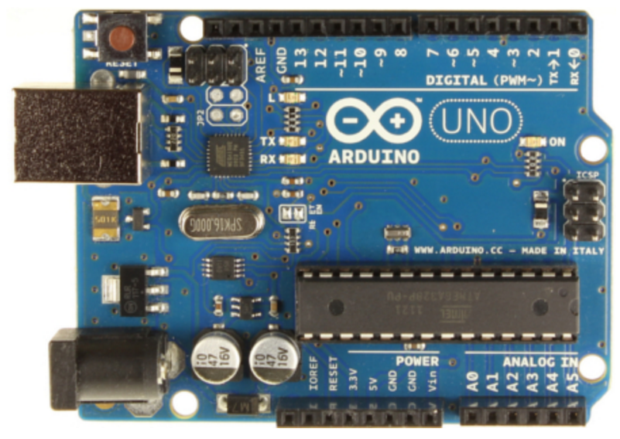
Figure 1: Arduino UNO R3

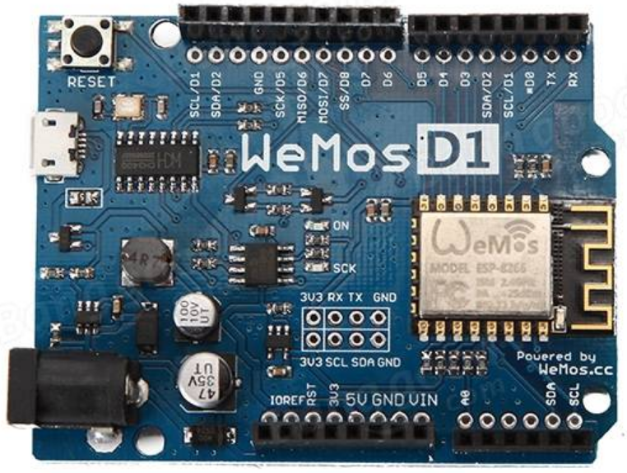
Figure 2: WeMos D1R2 board
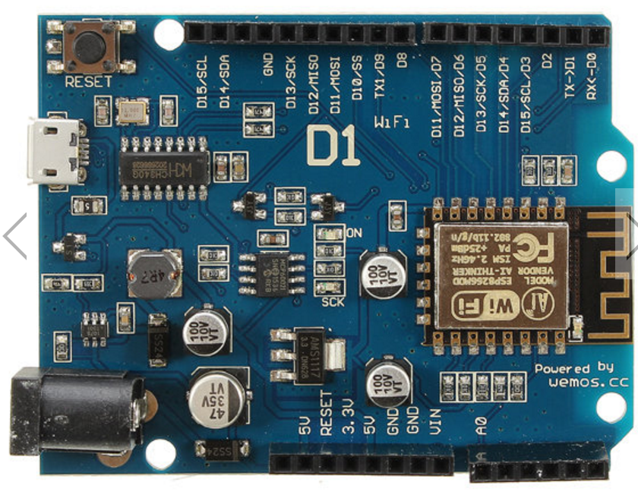
Figure 3: WeMos D1R1 board

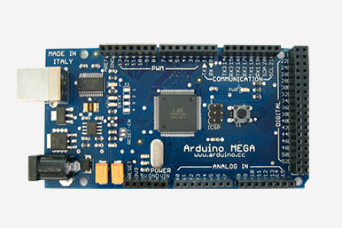
Figure 4: Arduino Mega

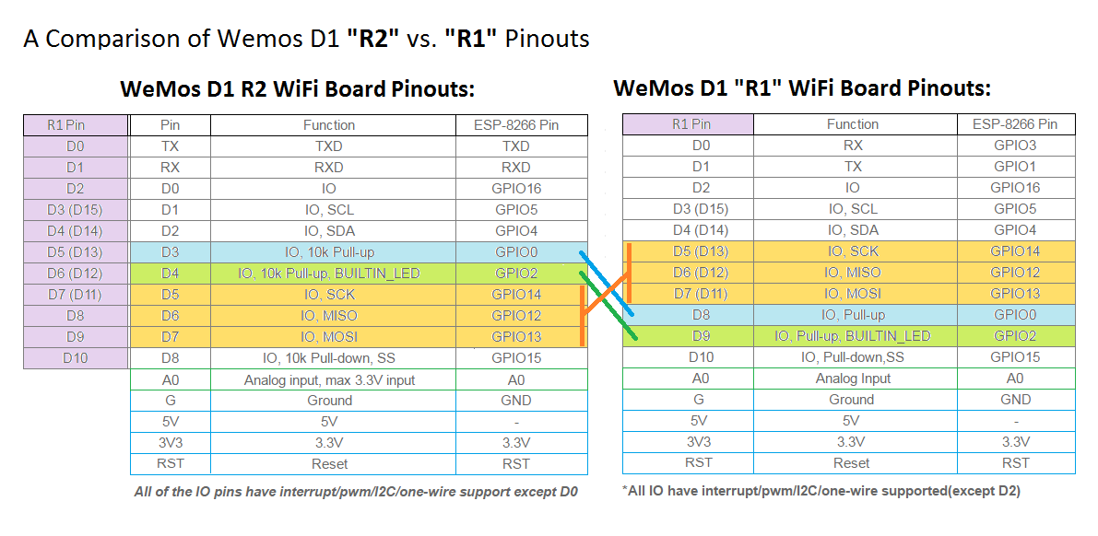

Specification of IPOCS board pinusage

Arduino UNO pin usage for Boosters:
GPIO00: Reserved Tx/RX
GPIO01: Reserved Tx/RX
GPIO02: Current enable section 1
GPIO~03: Current enable section 2
GPIO04: Current enable section 3
GPIO~05: Current enable section 4
GPIO~06: Current enable section 5
GPIO07: Current enable section 6
GPIO08: Temperature alarm
GPIO~09: Spare
GPIO10: IP&SD reserved
GPIO11: IP&SD reserved
GPIO12: IP&SD reserved
GPIO13: IP&SD reserved
A0: Current sense section 1
A1: Current sense section 2
A2: Current sense section 3
A3: Current sense section 4
A4: Current sense section 5
A5: Current sense section 6
Arduino UNO pin usage for relay pulse controlled switches with inbuilt frog polarity control:
GPIO00: Reserved Tx/RX
GPIO01: Reserved Tx/RX
GPIO02: Out Switch 1 throw
GPIO~03: Out Switch 2 throw
GPIO04: Out Switch 3 throw
GPIO~05: Out Switch 4 throw
GPIO~06: Out Switch 5 throw
GPIO07: Out Switch 6 throw
GPIO08: General Purpose I/O
GPIO~09: General Purpose I/O
GPIO10: IP&SD reserved
GPIO11: IP&SD reserved
GPIO12: IP&SD reserved
GPIO13: IP&SD reserved
A0: In Switch 1, Normal 0V dig<300, Undefined 400>dig<700, Thrown dig>800
A1: In Switch 2, Normal 0V dig<300, Undefined 400>dig<700, Thrown dig>800
A2: In Switch 3, Normal 0V dig<300, Undefined 400>dig<700, Thrown dig>800
A3: In Switch 4, Normal 0V dig<300, Undefined 400>dig<700, Thrown dig>800
A4: In Switch 5, Normal 0V dig<300, Undefined 400>dig<700, Thrown dig>800
A5: In Switch 6, Normal 0V dig<300, Undefined 400>dig<700, Thrown dig>800

Arduino UNO pin usage for Servo driven switches:
GPIO00: Reserved Tx/RX
GPIO01: Reserved Tx/RX
GPIO02: Frog Power control Switch 1
GPIO~03: Servo Out Switch 1 throw
GPIO04: Frog Power control Switch 2
GPIO~05: Servo Out Switch 2 throw
GPIO~06: Frog Power control Switch3
GPIO07: Servo Out Switch 3 throw
GPIO08: Frog Power control Switch 4
GPIO~09: Servo Out Switch 4 throw
GPIO10: IP&SD reserved
GPIO11: IP&SD reserved
GPIO12: IP&SD reserved
GPIO13: IP&SD reserved
A0: In Switch 1, Normal 0V dig<300, Undefined 400>dig<700, Thrown dig>800
A1: In Switch 2, Normal 0V dig<300, Undefined 400>dig<700, Thrown dig>800
A2: In Switch 3, Normal 0V dig<300, Undefined 400>dig<700, Thrown dig>800
A3: In Switch 4, Normal 0V dig<300, Undefined 400>dig<700, Thrown dig>800
A4: GPIN 1
A5: GPIN 2

Arduino UNO pin usage for General I/O:
GPIO00: Reserved Tx/RX
GPIO01: Reserved Tx/RX
GPIO02: GPIO1
GPIO~03: GPIO2
GPIO04: GPIO3
GPIO~05: GPIO4
GPIO~06: GPIO5
GPIO07: GPIO6
GPIO08: GPIO7
GPIO~09: GPIO8
GPIO10: IP&SD reserved
GPIO11: IP&SD reserved
GPIO12: IP&SD reserved
GPIO13: IP&SD reserved
A0: GPIN 1
A1: GPIN 2
A2: GPIN 3
A3: GPIN 4
A4: GPIN 5
A5: GPIN 6
Arduino Mega 2560 PIN mapping table
Pin Number | Pin Name | Board edge Pin Name
1 | PG5 ( OC0B ) | Digital pin 4 (PWM)
2 | PE0 ( RXD0/PCINT8 ) | Digital pin 0 (RX0)
3 | PE1 ( TXD0 ) | Digital pin 1 (TX0)
4 | PE2 ( XCK0/AIN0 )
5 | PE3 ( OC3A/AIN1 ) | Digital pin 5 (PWM)
6 | PE4 ( OC3B/INT4 ) | Digital pin 2 (PWM)
7 | PE5 ( OC3C/INT5 ) | Digital pin 3 (PWM)
8 | PE6 ( T3/INT6 )
9 | PE7 ( CLKO/ICP3/INT7 )
10 | VCC | VCC
11 | GND | GND
12 | PH0 ( RXD2 ) | Digital pin 17 (RX2)
13 | PH1 ( TXD2 ) | Digital pin 16 (TX2)
14 | PH2 ( XCK2 )
15 | PH3 ( OC4A ) | Digital pin 6 (PWM)
16 | PH4 ( OC4B ) | Digital pin 7 (PWM)
17 | PH5 ( OC4C ) | Digital pin 8 (PWM)
18 | PH6 ( OC2B ) | Digital pin 9 (PWM)
19 | PB0 ( SS/PCINT0 ) | Digital pin 53 (SS)
20 | PB1 ( SCK/PCINT1 ) | Digital pin 52 (SCK)
21 | PB2 ( MOSI/PCINT2 ) | Digital pin 51 (MOSI)
22 | PB3 ( MISO/PCINT3 ) | Digital pin 50 (MISO)
23 | PB4 ( OC2A/PCINT4 ) | Digital pin 10 (PWM)
24 | PB5 ( OC1A/PCINT5 ) | Digital pin 11 (PWM)
25 | PB6 ( OC1B/PCINT6 ) | Digital pin 12 (PWM)
26 | PB7 ( OC0A/OC1C/PCINT7 ) | Digital pin 13 (PWM)
27 | PH7 ( T4 )
28 | PG3 ( TOSC2 )
29 | PG4 ( TOSC1 )
30 | RESET | RESET
31 | VCC | VCC
32 | GND | GND
33 | XTAL2 | XTAL2
34 | XTAL1 | XTAL1
35 | PL0 ( ICP4 ) | Digital pin 49
36 | PL1 ( ICP5 ) | Digital pin 48
37 | PL2 ( T5 ) | Digital pin 47
38 | PL3 ( OC5A ) | Digital pin 46 (PWM)
39 | PL4 ( OC5B ) | Digital pin 45 (PWM)
40 | PL5 ( OC5C ) | Digital pin 44 (PWM)
41 | PL6 | Digital pin 43
42 | PL7 | Digital pin 42
43 | PD0 ( SCL/INT0 ) | Digital pin 21 (SCL)
44 | PD1 ( SDA/INT1 ) | Digital pin 20 (SDA)
45 | PD2 ( RXDI/INT2 ) | Digital pin 19 (RX1)
46 | PD3 ( TXD1/INT3 ) | Digital pin 18 (TX1)
47 | PD4 ( ICP1 )
48 | PD5 ( XCK1 )
49 | PD6 ( T1 )
50 | PD7 ( T0 ) | Digital pin 38
51 | PG0 ( WR ) | Digital pin 41
52 | PG1 ( RD ) | Digital pin 40
53 | PC0 ( A8 ) | Digital pin 37
54 | PC1 ( A9 ) | Digital pin 36
55 | PC2 ( A10 ) | Digital pin 35
56 | PC3 ( A11 ) | Digital pin 34
57 | PC4 ( A12 ) | Digital pin 33
58 | PC5 ( A13 ) | Digital pin 32
59 | PC6 ( A14 ) | Digital pin 31
60 | PC7 ( A15 ) | Digital pin 30
61 | VCC | VCC
62 | GND | GND
63 | PJ0 ( RXD3/PCINT9 ) | Digital pin 15 (RX3)
64 | PJ1 ( TXD3/PCINT10 ) | Digital pin 14 (TX3)
65 | PJ2 ( XCK3/PCINT11 )
66 | PJ3 ( PCINT12 )
67 | PJ4 ( PCINT13 )
68 | PJ5 ( PCINT14 )
69 | PJ6 ( PCINT 15 )
70 | PG2 ( ALE ) | Digital pin 39
71 | PA7 ( AD7 ) | Digital pin 29
72 | PA6 ( AD6 ) | Digital pin 28
73 | PA5 ( AD5 ) | Digital pin 27
74 | PA4 ( AD4 ) | Digital pin 26
75 | PA3 ( AD3 ) | Digital pin 25
76 | PA2 ( AD2 ) | Digital pin 24
77 | PA1 ( AD1 ) | Digital pin 23
78 | PA0 ( AD0 ) | Digital pin 22
79 | PJ7
80 | VCC | VCC
81 | GND | GND
82 | PK7 ( ADC15/PCINT23 ) | Analog pin 15
83 | PK6 ( ADC14/PCINT22 ) | Analog pin 14
84 | PK5 ( ADC13/PCINT21 ) | Analog pin 13
85 | PK4 ( ADC12/PCINT20 ) | Analog pin 12
86 | PK3 ( ADC11/PCINT19 ) | Analog pin 11
87 | PK2 ( ADC10/PCINT18 ) | Analog pin 10
88 | PK1 ( ADC9/PCINT17 ) | Analog pin 9
89 | PK0 ( ADC8/PCINT16 ) | Analog pin 8
90 | PF7 ( ADC7 ) | Analog pin 7
91 | PF6 ( ADC6 ) | Analog pin 6
92 | PF5 ( ADC5/TMS ) | Analog pin 5
93 | PF4 ( ADC4/TMK ) | Analog pin 4
94 | PF3 ( ADC3 ) | Analog pin 3
95 | PF2 ( ADC2 ) | Analog pin 2
96 | PF1 ( ADC1 ) | Analog pin 1
97 | PF0 ( ADC0 ) | Analog pin 0
98 | AREF | Analog Reference
99 | GND | GND
100 | AVCC | VCC

Arduino MEGA pin usage for General I/O:
GPIO00: Reserved Tx/RX
GPIO01: Reserved Tx/RX
GPIO~02: GPIO1
GPIO~03: GPIO2
GPIO~04: GPIO3
GPIO~05: GPIO5
GPIO~06: GPIO5
GPIO~07: GPIO6
GPIO~08: GPIO7
GPIO~09: GPIO8
GPIO10: IP&SD reserved
GPIO11: IP&SD reserved
GPIO12: IP&SD reserved
GPIO13: IP&SD reserved
GPIO14: GPIO9
GPIO15: GPIO10
GPIO16: GPIO11
GPIO17: GPIO12
GPIO18: GPIO13
GPIO19: GPIO14
GPIO20: GPIO15
GPIO21: GPIO16
GPIO22: GPIO17
GPIO23: GPIO18
GPIO24: GPIO19
GPIO25: GPIO20
GPIO26: GPIO21
GPIO27: GPIO22
GPIO28: GPIO23
GPIO29: GPIO24
GPIO30: GPIO25
GPIO31: GPIO26
GPIO32: GPIO27
GPIO33: GPIO28
GPIO34: GPIO29
GPIO35: GPIO30
GPIO36: GPIO31
GPIO37: GPIO32
GPIO38: GPIO33
GPIO39: GPIO34
GPIO40: GPIO35
GPIO41: GPIO36
GPIO42: GPIO37
GPIO43: GPIO38
GPIO~44: GPIO39
GPIO~45: GPIO40
GPIO~46: GPIO41
GPIO47: GPIO42
GPIO48: GPIO43
GPIO49: GPIO44
GPIO50: GPIO45
GPIO51: GPIO46
GPIO52: GPIO47
GPIO53: GPIO48
A0: GPIN 1
A1: GPIN 2
A2: GPIN 3
A3: GPIN 4
A4: GPIN 5
A5: GPIN 6
A6: GPIN 7
A7: GPIN 8
A8: GPIN 9
A9: GPIN 10
A10: GPIN 11
A11: GPIN 12
A12: GPIN 13
A13: GPIN 14
A14: GPIN 15
A15: GPIN 16

Arduino MEGA pin usage for relay pulse controlled switches with inbuilt frog polarity control:
GPIO00: Reserved Tx/RX
GPIO01: Reserved Tx/RX
GPIO~02: SWITCH1 throw
GPIO~03: SWITCH2 throw
GPIO~04: SWITCH3 throw
GPIO~05: SWITCH4 throw
GPIO~06: SWITCH5 throw
GPIO~07: SWITCH6 throw
GPIO~08: SWITCH7 throw
GPIO~09: SWITCH8 throw
GPIO10: IP&SD reserved
GPIO11: IP&SD reserved
GPIO12: IP&SD reserved
GPIO13: IP&SD reserved
GPIO14: SWITCH9 throw
GPIO15: SWITCH10 throw
GPIO16: SWITCH11 throw
GPIO17: SWITCH12 throw
GPIO18: SWITCH13 throw
GPIO19: SWITCH14 throw
GPIO20: SWITCH15 throw
GPIO21: SWITCH16 throw
GPIO22: GPIO1
GPIO23: GPIO2
GPIO24: GPIO3
GPIO25: GPIO4
GPIO26: GPIO5
GPIO27: GPIO6
GPIO28: GPIO7
GPIO29: GPIO8
GPIO30: GPIO9
GPIO31: GPIO10
GPIO32: GPIO11
GPIO33: GPIO12
GPIO34: GPIO13
GPIO35: GPIO14
GPIO36: GPIO15
GPIO37: GPIO16
GPIO38: GPIO17
GPIO39: GPIO18
GPIO40: GPIO19
GPIO41: GPIO20
GPIO42: GPIO21
GPIO43: GPIO22
GPIO~44: GPIO23
GPIO~45: GPIO24
GPIO~46: GPIO25
GPIO47: GPIO26
GPIO48: GPIO27
GPIO49: GPIO28
GPIO50: GPIO29
GPIO51: GPIO30
GPIO52: GPIO31
GPIO53: GPIO32
A0: In Switch 1, Normal 0V dig<300, Undefined 400>dig<700, Thrown dig>800
A1: In Switch 2, Normal 0V dig<300, Undefined 400>dig<700, Thrown dig>800
A2: In Switch 3, Normal 0V dig<300, Undefined 400>dig<700, Thrown dig>800
A3: In Switch 4, Normal 0V dig<300, Undefined 400>dig<700, Thrown dig>800
A4: In Switch 5, Normal 0V dig<300, Undefined 400>dig<700, Thrown dig>800
A5: In Switch 6, Normal 0V dig<300, Undefined 400>dig<700, Thrown dig>800
A6: In Switch 7, Normal 0V dig<300, Undefined 400>dig<700, Thrown dig>800
A7: In Switch 8, Normal 0V dig<300, Undefined 400>dig<700, Thrown dig>800
A8: In Switch 9, Normal 0V dig<300, Undefined 400>dig<700, Thrown dig>800
A9: In Switch 10, Normal 0V dig<300, Undefined 400>dig<700, Thrown dig>800
A10: In Switch 11, Normal 0V dig<300, Undefined 400>dig<700, Thrown dig>800
A11: In Switch 12, Normal 0V dig<300, Undefined 400>dig<700, Thrown dig>800
A12: In Switch 13, Normal 0V dig<300, Undefined 400>dig<700, Thrown dig>800
A13: In Switch 14, Normal 0V dig<300, Undefined 400>dig<700, Thrown dig>800
A14: In Switch 15, Normal 0V dig<300, Undefined 400>dig<700, Thrown dig>800
A15: In Switch 16, Normal 0V dig<300, Undefined 400>dig<700, Thrown dig>800

Arduino MEGA pin usage for servo motor controlled switches with frog polarity control:
GPIO00: Reserved Tx/RX
GPIO01: Reserved Tx/RX
GPIO~02: SWITCH1 throw
GPIO~03: SWITCH2 throw
GPIO~04: SWITCH3 throw
GPIO~05: SWITCH4 throw
GPIO~06: SWITCH5 throw
GPIO~07: SWITCH6 throw
GPIO~08: SWITCH7 throw
GPIO~09: SWITCH8 throw
GPIO10: IP&SD reserved
GPIO11: IP&SD reserved
GPIO12: IP&SD reserved
GPIO13: IP&SD reserved
GPIO14: SWITCH9 throw
GPIO15: SWITCH10 throw
GPIO16: SWITCH11 throw
GPIO17: SWITCH12 throw
GPIO18: SWITCH13 throw
GPIO19: SWITCH14 throw
GPIO20: SWITCH15 throw
GPIO21: SWITCH16 throw
GPIO22: Frog polarity relay switch 1
GPIO23: Frog polarity relay switch 2
GPIO24: Frog polarity relay switch 3
GPIO25: Frog polarity relay switch 4
GPIO26: Frog polarity relay switch 5
GPIO27: Frog polarity relay switch 6
GPIO28: Frog polarity relay switch 7
GPIO29: Frog polarity relay switch 8
GPIO30: Frog polarity relay switch 9
GPIO31: Frog polarity relay switch 10
GPIO32: Frog polarity relay switch 11
GPIO33: Frog polarity relay switch 12
GPIO34: Frog polarity relay switch 13
GPIO35: Frog polarity relay switch 14
GPIO36: Frog polarity relay switch 15
GPIO37: Frog polarity relay switch 16
GPIO38: GPIO1
GPIO39: GPIO2
GPIO40: GPIO3
GPIO41: GPIO4
GPIO42: GPIO5
GPIO43: GPIO6
GPIO~44: GPIO7
GPIO~45: GPIO8
GPIO~46: GPIO9
GPIO47: GPIO10
GPIO48: GPIO11
GPIO49: GPIO12
GPIO50: GPIO13
GPIO51: GPIO14
GPIO52: GPIO15
GPIO53: GPIO16
A0: In Switch 1, Normal 0V dig<300, Undefined 400>dig<700, Thrown dig>800
A1: In Switch 2, Normal 0V dig<300, Undefined 400>dig<700, Thrown dig>800
A2: In Switch 3, Normal 0V dig<300, Undefined 400>dig<700, Thrown dig>800
A3: In Switch 4, Normal 0V dig<300, Undefined 400>dig<700, Thrown dig>800
A4: In Switch 5, Normal 0V dig<300, Undefined 400>dig<700, Thrown dig>800
A5: In Switch 6, Normal 0V dig<300, Undefined 400>dig<700, Thrown dig>800
A6: In Switch 7, Normal 0V dig<300, Undefined 400>dig<700, Thrown dig>800
A7: In Switch 8, Normal 0V dig<300, Undefined 400>dig<700, Thrown dig>800
A8: In Switch 9, Normal 0V dig<300, Undefined 400>dig<700, Thrown dig>800
A9: In Switch 10, Normal 0V dig<300, Undefined 400>dig<700, Thrown dig>800
A10: In Switch 11, Normal 0V dig<300, Undefined 400>dig<700, Thrown dig>800
A11: In Switch 12, Normal 0V dig<300, Undefined 400>dig<700, Thrown dig>800
A12: In Switch 13, Normal 0V dig<300, Undefined 400>dig<700, Thrown dig>800
A13: In Switch 14, Normal 0V dig<300, Undefined 400>dig<700, Thrown dig>800
A14: In Switch 15, Normal 0V dig<300, Undefined 400>dig<700, Thrown dig>800
A15: In Switch 16, Normal 0V dig<300, Undefined 400>dig<700, Thrown dig>800

